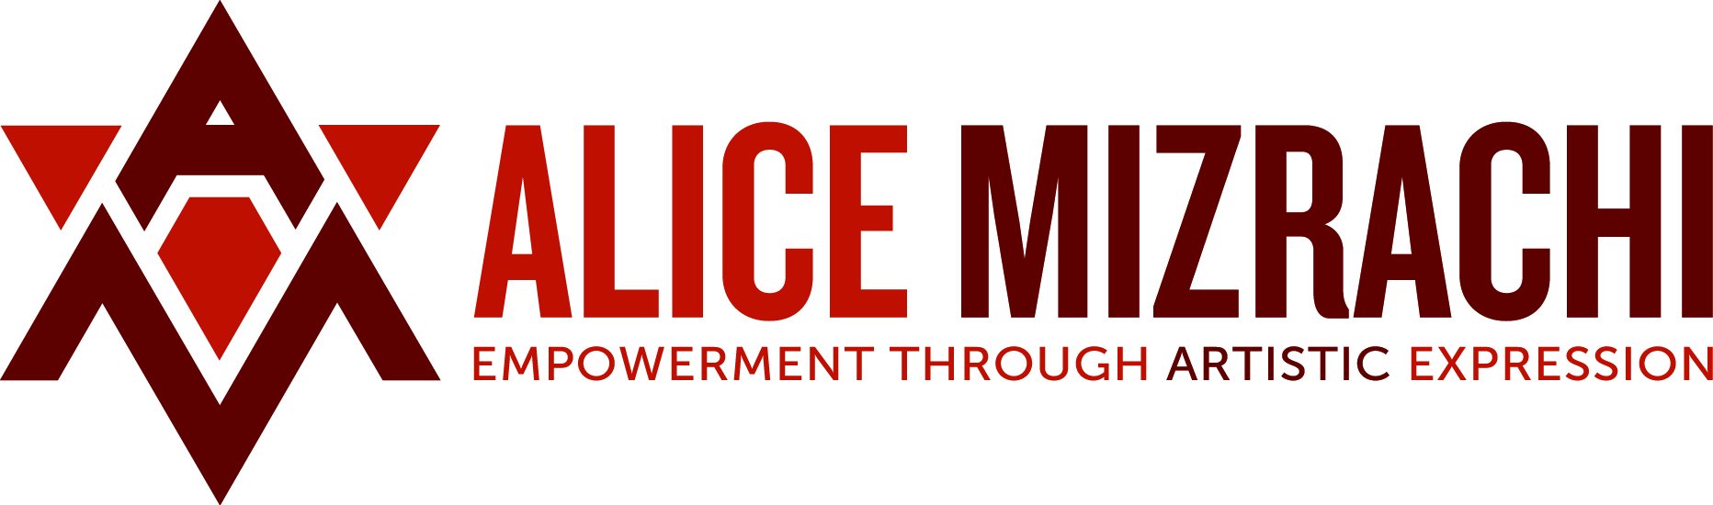

Alice Mizrachi is a New York based mixed media artist. Her practice includes work as a muralist, fine artist, educator, and curator. Grounded in deep compassion for the human experience across borders, Mizrachi explores both the spiritual and physical dimensions of being human, and in particular, female. Often times, the female figure in various mythical iterations intersects with earthbound feminine forms as a means to communicate and transmit social consciousness. Mizrachi’s intentions include the empowerment of self and others through artistic expression, as well as advocacy for women, youth, and the environment. Family, community, and tribe are also recurring themes and are approached as active spaces of shared engagement.

In recent years, Mizrachi’s studio practice has developed into a testing ground for explorations in assemblage, sculpture, and installation that has transformed both her painting practice and decades of work as a muralist. Moving beyond paint, her small-scale pieces have become sculptural drawings and her murals have become outdoor wall installations. Both styles of work have taken on new life as three-dimensional geometric forms.

Mizrachi’s mix of modernist influences and her identification with her personhood as a woman of Middle Eastern descent who is first generation American, are reflected through intuitive ritualistic gestures and articulations in much of her work. Her spontaneous approach allows her preference for line, and the deconstruction and reconstruction of figurative elements, to reveal a human hand in the making of her work, an intentional maneuver in an increasingly technological age. A discourse around gender is a subtext to much of the work and is most evident in her poetic use of rough textures, found materials, and raw energy.

            Alice has worked as an arts educator, developed curriculum, and presented on panels for a variety of organizations, including: BRIC Arts, The Laundromat Project, The Studio Museum in Harlem, HI-ARTS, Miami Light Project, Brown University, and The Devos Institute of Arts Management among others. Her artwork has been featured at the Museum of the City of New York, the National Museum of Women in the Arts and Albright-Knox Museum; and, in a variety of publications including *2Create*, *Outdoor Gallery: NYC*, the New York Times, Huffington Post, and Architectural Digest. Alice received a BFA from Parsons School of Design, has received grants from The Puffin Foundation and The Ford Foundation, and held residencies at Fountainhead in Miami and Honeycomb Arts In Buenos Aires in 2017. Alice Mizrachi’s studio is currently located at Bell Ans.